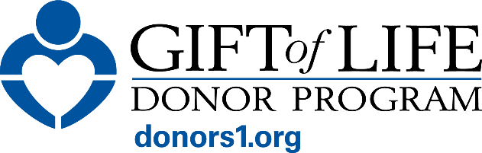

ORGAN AND TISSUE DONATION

Learn the Facts. Help Us End the Transplant Waitlist.

Lives Are at Stake
- More than 100,000 children and adults in the U.S. need an organ transplant to survive.
- Each day, 13 people die while waiting for a transplant.
- Every 8 minutes, another person is added to the national waitlist.
- In our region alone, approximately 4,500 people of all ages are waiting for a transplant.

The Power of Organ & Tissue Donation
- One donor can make an extraordinary difference:
  - One organ donor can save up to 8 lives.
  - One tissue donor can transform the lives of about 100 people.
- Organ donation can include kidneys, liver, lungs, heart, pancreas and intestines.
- Tissue donation can include bone to repair fractures and prevent amputations, skin to treat burn patients and support reconstructive surgery, including after breast cancer, heart valves to repair life-threatening defects and corneas to restore eyesight.

Gift of Life Donor Program
- Works 24/7 to support families through the donation process and coordinate the recovery of organs and tissues from deceased donor heroes.
- Serves 11.3 million people across the eastern half of Pennsylvania, southern New Jersey and Delaware.
- Partners with 123 acute care hospitals, 12 regional transplant centers and more than 100 transplant centers nationwide.
- Provides the most comprehensive array of services of any organ procurement organization (OPO) in the U.S.

Gift of Life’s Impact
2025 Milestones
- Coordinated 1,955 organ transplants, the most in U.S. history.
- 984 kidney transplants, the most in the U.S. for the tenth consecutive year.
- 508 liver transplants, the most in U.S. history.
- 180 heart transplants, the most in the U.S.
- 725 organ donor heroes, the most in Gift of Life’s history of 50+ years.
- 2,406 cornea donors, most in Gift of Life’s history.
Gift of Life’s Impact (continued)
Since the start of the national donation system in 1988:
- Most donor heroes (15,586) and organs transplanted (43,108) of any U.S. OPO.
- More than two million tissue transplants.
- Most lives saved and healed of any U.S. OPO.

National Leader in Kidney Transplants
- Total kidney transplants coordinated: 22,756 — the most in U.S. history.
- More than a half million people in the U.S. are suffering from End-Stage Renal Disease, with more than 90,000 awaiting a kidney transplant.

National Leader in Innovation
Gift of Life’s commitment to implementing new organ preservation technologies effectively and rapidly is opening doors for more families to save lives.

Organ Donation: What to Know
- Registering as an organ and tissue donor is a powerful act of generosity that brings hope to patients and their families.
- More than half of people on the U.S. transplant waitlist are people of color, underscoring the importance of diverse donors.
- All major religions support organ donation as an expression of compassion and care for others.
- Fewer than 2% of deaths occur under circumstances that allow for organ donation, making every registered donor essential.
- Everyone has the potential to be a donor hero regardless of age, health or medical history. At the time of death, medical tests are done to determine suitability for donation.

ACT NOW: Help Save Lives
- Registering as a donor takes less than one minute at donors1.org.
- Learn the facts, make an informed decision and share it with your loved ones.

Learn more at donors1.org.

#####

