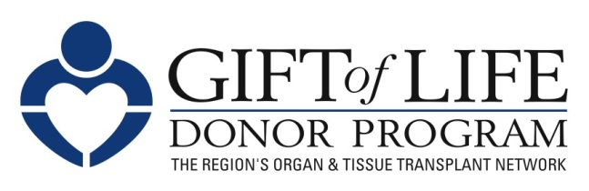

FOR IMMEDIATE RELEASE Contact:
May 10, 2024 Kendall Bunch
kbunch@donors1.org
Mobile: 267-643-5774

27th Annual Gift of Life Donor Dash Draws 15,000+ Supporters,
Raises More Than $675,000 for Life-Saving Organ Donation

Philadelphia, PA – More than 15,000 people from the greater Philadelphia region and beyond celebrated National Donate Life Month and the ultimate act of generosity – organ donation – at the 27th Gift of Life Donor Dash on Sunday, April 28. Held annually, the Dash raises awareness of the urgent need for more registered donors to save lives.
“We’re humbled and gratified by the outpouring of community support that made this year’s event the largest and most successful in the history of the Donor Dash. Thank you to all our sponsors, participants, volunteers, and community partners for helping us raise awareness and critical funding so together we can save more lives,” said Richard D. Hasz, Jr., MFS, CPTC, President and CEO of Gift of Life Donor Program.

The Dash, held for the first time at the scenic and spacious Philadelphia Navy Yard, served as the start of a one-year commemoration of Gift of Life Donor Program’s 50 years of service. Highlights included:

- 15,000+ participants
- 340+ Teams
- 200+ Volunteers
- $675,000+ raised
- Virtual Dash in 30 states and Washington, D.C.
- Special live performance by Hip Hop artist Philadelphia Freeway, a kidney transplant recipient, father of a donor hero and a Gift of Life volunteer ambassador

Funds raised support programs for donor families and transplant recipients along with critically important public education outreach to inspire more people to sign up as an organ donor. Anyone who was not able to attend the Dash but would still like to donate may visit donordash.org.

This year’s expanded Donor Dash included 5K and 10K runs, a Kids Fun Run, lawn games, food trucks, community organizations, and health resources. The emotional highpoint was a 3K walk featuring hundreds of teams, many in custom-designed team t-shirts, carrying colorful signs to honor donor heroes, celebrate transplant recipients who received a second chance at life and show support for patients on the transplant waitlist. Entertainment included the PME Drumline, DJ Gary O, Anton Milton & Glorified, Philadelphia School of Rock, and Temple Jazz Ensemble.

The Donor Dash was started in 1996 by volunteer Claire Braverman, whose husband, Mickey, died waiting for a liver transplant. Today, more than 100,000 children and adults nationwide need an organ transplant to survive; 18 people die each day waiting.

The following generous sponsors made Gift of Life’s 27th Annual Donor Dash possible:

- Presenting Sponsor:
  - Solvita
- Platinum Sponsor:
  - MTF Biologics
- Diamond Sponsors:
  - AltruVision, Nemours Children’s Health, Quick Courier Service Inc., Temple Health, Venture Jets
- Silver Sponsors:
  - Global Transplant Solutions, Organ Recovery Systems
- Bronze Sponsors:
  - Eurofins, Gallagher, Jefferson Health, Nationwide Organ Recovery Transplant Alliance, Penn Medicine Transplant Institute
- Supporters:
  - AmeriHealth Caritas, ChristianaCare Kidney Transplant Program, Cornerstone Institutional Investors, Inc., Cozen O’Connor, Paragonix Technologies, Wegmans
- Patrons
  - Artivion, Inc., Penn State Health – Hershey Medical Center, St. Christopher’s Hospital for Children, UPMC Pinnacle

About Gift of Life Donor Program
Gift of Life Donor Program, founded in 1974 and headquartered in Philadelphia, is the federally designated organ procurement organization (OPO) for the eastern half of Pennsylvania, southern New Jersey, and Delaware. It works with 126 acute care hospitals and 12 transplant centers in its region, as well as hundreds of transplant centers throughout the country, to provide the most comprehensive array of services available in the U.S. to the donation and transplantation community. Thanks to the generosity of its community, Gift of Life has coordinated 14,196 donors and 39,469 organs for transplant, the most of any OPO in the country since the inception of our national donation system in 1988. Overall, Gift of Life has coordinated more than 59,000 organs and more than two million tissue transplants since its founding. One organ donor can save the lives of up to eight people, and a tissue donor can improve the lives of 100 others. Learn more and sign up at donors1.org.

#####

