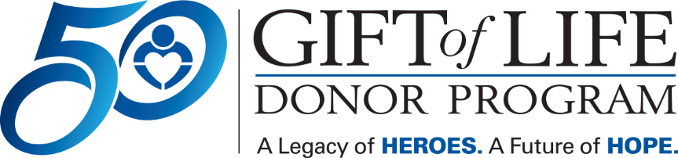 [HOSPITAL LOGO]

FOR IMMEDIATE RELEASE Contact: [Hospital PR Contact information]

Gift of Life Donor Program and [HOSPITAL NAME]
Promote Organ Donation to Help Save Lives
– Gift of Life Encourages Individuals to Celebrate National Donate Life Month
by Registering to Become an Organ, Tissue and Cornea Donor –

Philadelphia, Month XX, 2025 – Each day, 17 people in the United States die while waiting for a life-saving organ transplant. [HOSPITAL NAME] is pleased to join Gift of Life Donor Program to promote organ and tissue donation throughout April as part of National Donate Life Month. Gift of Life is encouraging individuals to register to become an organ, tissue and cornea donor, which is as easy as visiting donors1.org.

"Transplantation is one of the most significant advancements in the history of medicine. Still, the need for organs is far greater than the number available," said Richard D. Hasz, President and CEO of Gift of Life. "Gift of Life’s mission includes educating our community about the powerful impact they can make by taking less than a minute to register as an organ, tissue and cornea donor."

“As a health system, we are uniquely positioned to not only tend to the health of our patients, but to inspire our community to be mindful of wellness in all aspects of life,” said [HOSPITAL PRESIDENT/CEO]. “The more people we can inspire to become organ donors, the better we can serve our mission to be advocates for the well-being of our entire community.”

Individuals are encouraged to talk with family members and friends about registering as a donor. One organ donor can save up to eight lives and a tissue donor can improve the lives of about 100 others. To sign up, visit donors1.org.

Some important facts about organ, tissue and cornea donation:

- Anyone can be a potential donor regardless of age, race or medical history.

- About 5,000 children and adults in the region await life-saving organ transplants. Thousands of others could benefit from life-enhancing tissue transplants.

- With more than 90,000 people across the nation awaiting a kidney, it is the organ in greatest demand, followed by liver, heart and lungs.

- Because conditions such as diabetes and hypertension are often more prevalent in the multicultural community, these individuals make up 60 percent of those on the national organ transplant list.

About Gift of Life Donor Program

Gift of Life Donor Program, founded in 1974 and headquartered in Philadelphia, is the federally designated organ procurement organization (OPO) for the eastern half of Pennsylvania, southern New Jersey and Delaware serving 11.3 million people. It works with 124 acute care hospitals and 12 transplant centers in its region, as well as hundreds of transplant centers throughout the country, to provide the most comprehensive array of services available in the U.S. to the donation and transplantation community. Thanks to the generosity of its community, Gift of Life has coordinated 14,860 donors and 41,140 organs for transplant, the most of any OPO in the country since the inception of our national donation system in 1988. Overall, Gift of Life has coordinated more than 62,000 organs and more than two million tissue transplants since its founding. One organ donor can save the lives of up to eight people and a tissue donor can improve the lives of 100 others. In honor of its 50 years of saving lives, Gift of Life is rallying the community to sign up 50,000 more organ donors and provide hope to the thousands waiting for a transplant. Learn more and sign up at donors1.org.

About [HOSPITAL]

# # #

