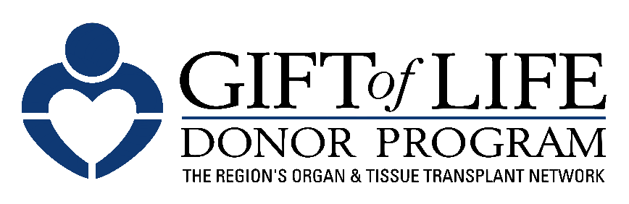 [HOSPITAL LOGO]

FOR IMMEDIATE RELEASE Contact: [Hospital PR Contact information]

Gift of Life Donor Program and [HOSPITAL NAME]
Promote Organ Donation to Help Save Lives
– Gift of Life Encourages Individuals to Generate Hope, Advocacy and Passion
by Registering to Become an Organ, Tissue and Cornea Donor –

Philadelphia, Month XX, 2024 – Each day, 17 people in the United States die while waiting for a life-saving organ transplant. [HOSPITAL NAME] is pleased to join The Hospital & Healthsystem Association of Pennsylvania (HAP) and Gift of Life Donor Program to inspire hope, advocacy and passion as part of a statewide campaign to promote organ and tissue donation. Gift of Life is encouraging individuals to register to become an organ, tissue and cornea donor which is as easy as visiting donors1.org.

"Transplantation is one of the most significant advancements in the history of medicine, with 95 percent of Americans saying they support organ donation. Still, the need for organs is far greater than the number available," said Richard D. Hasz, President and CEO of Gift of Life. "Gift of Life’s mission includes educating our community about the powerful impact they can make by taking less than a minute to register as an organ, tissue and cornea donor."

“As a health system, we are uniquely positioned to not only tend to the health of our patients, but to inspire our community to be mindful of wellness in all aspects of life,” said [HOSPITAL PRESIDENT/CEO]. “The more people we can inspire to become organ donors, the better we can serve our mission to be advocates for the well-being of our entire community.”

Individuals are encouraged to talk with family members and friends about registering as a donor. One organ donor can save up to eight lives and a tissue donor can improve the lives of about 100 others. To sign up, visit donors1.org.

Some important facts about organ, tissue and cornea donation:

- Anyone can be a potential donor regardless of age, race or medical history.

- About 5,000 children and adults in the region await life-saving organ transplants. Thousands of others could benefit from life-enhancing tissue transplants.

- Fewer than 50 percent of registered drivers in Pennsylvania have designated themselves as organ and tissue donors.

- With more than 90,000 people across the nation awaiting a kidney, it is the organ in greatest demand, followed by liver, heart and lungs.

- Conditions such as diabetes and hypertension are often more prevalent in the multicultural community. People of color make up 60 percent of those on the national organ transplant list.

About Gift of Life Donor Program

Gift of Life Donor Program, founded in 1974 and headquartered in Philadelphia, is the federally designated organ procurement organization (OPO) for the eastern half of Pennsylvania, southern New Jersey, and Delaware. It works with 126 acute care hospitals and 12 transplant centers in its region, as well as hundreds of transplant centers throughout the country, to provide the most comprehensive array of services available in the U.S. to the donation and transplantation community. Thanks to the generosity of its community, Gift of Life has coordinated 14,196 donors and 39,469 organs for transplant, the most of any OPO in the country since the inception of our national donation system in 1988. Overall, Gift of Life has coordinated more than 59,000 organs and more than two million tissue transplants since its founding. One organ donor can save the lives of up to eight people, and a tissue donor can improve the lives of 100 others. For more information or to register, visit donors1.org.

About [HOSPITAL]

# # #

