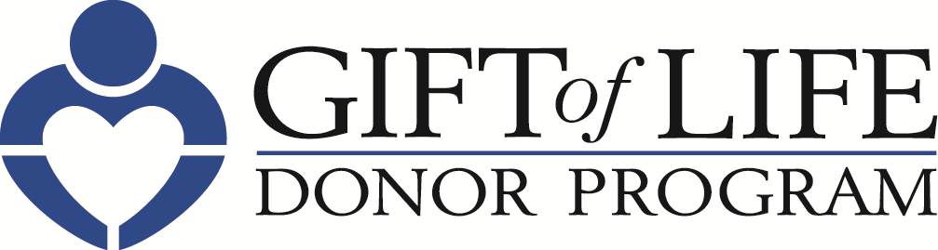 [HOSPITAL LOGO]

FOR IMMEDIATE RELEASE Contact: [Hospital PR Contact information]

Gift of Life Donor Program and [HOSPITAL NAME]
Promote Organ Donation to Help Save Lives
– Gift of Life Encourages Individuals to Celebrate National Donate Life Month
by Registering to Become an Organ, Tissue and Cornea Donor –

Philadelphia, Month XX, 2022 – Each day, 20 people in the United States die while waiting for a life-saving organ transplant. [HOSPITAL NAME] is pleased to join Gift of Life Donor Program and organ procurement organizations throughout the country to promote organ and tissue donation throughout April as part of National Donate Life Month. Gift of Life is encouraging individuals to register to become an organ, tissue and cornea donor, which is as easy as visiting donors1.org.

"Transplantation is one of the most significant advancements in the history of medicine, with 95% of Americans saying they support organ donation. Still, the need for organs is far greater than the number available," said Richard D. Hasz, President and CEO of Gift of Life. "Gift of Life’s mission includes educating our community about the powerful impact they can make by taking just 30 seconds to register as an organ, tissue and cornea donor."

“As a health system, we are uniquely positioned to not only tend to the health of our patients, but to inspire our community to be mindful of wellness in all aspects of life,” said [HOSPITAL PRESIDENT/CEO]. “The more people we can inspire to become organ donors, the better we can serve our mission to be advocates for the well-being of our entire community.”

Individuals are encouraged to talk with family members and friends about registering as a donor. One organ donor can save up to eight lives and a tissue donor can improve the lives of more than 100 others. To sign up, visit donors1.org.

Some important facts about organ, tissue and cornea donation:

- Anyone can be a potential donor regardless of age, race or medical history.

- More than 5,000 children and adults in the region await life-saving organ transplants. Thousands of others could benefit from life-enhancing tissue transplants.

- With more than 95,000 people across the nation awaiting a kidney, it is the organ in greatest demand, followed by liver, heart and lungs.

- Because conditions such as diabetes and hypertension are often more prevalent in the multicultural community, these individuals make up more than 50 percent of those on the national organ transplant list.

About Gift of Life Donor Program

Gift of Life Donor Program is the non-profit, federally designated organ procurement organization, working with 129 acute care hospitals and 14 transplant centers to serve 11.3 million people in the eastern half of Pennsylvania, southern New Jersey, and Delaware. Thanks to its compassionate community, for the past 14 years, Gift of Life has coordinated the most organ donors in the United States. Its annual donation rate, most recently 62 organ donors-per-million-population, ranks among the highest in the world. Since 1974, Gift of Life has coordinated more than 55,000 organs for transplant, and more than two million tissue transplants have resulted from the generosity of donors and their families. One organ donor can save the lives of up to eight people, and a tissue donor can improve the lives of more than 100 others. For more information or to register, visit donors1.org.

About [HOSPITAL]

# # #

