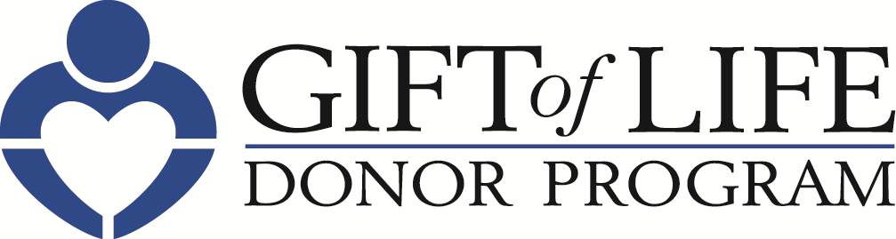 [HOSPITAL LOGO]

FOR IMMEDIATE RELEASE Contact: [Hospital PR Contact information]

Gift of Life Donor Program and [HOSPITAL NAME]
Promote Organ Donation to Help Save Lives
– Gift of Life Encourages Individuals to Generate Hope, Advocacy and Passion
by Registering to Become an Organ, Tissue and Cornea Donor –

Philadelphia, Month XX, 2020 – Each day, 20 people in the United States die while waiting for a life-saving organ transplant. [HOSPITAL NAME] is pleased to join the Hospital & Healthsystem Association of Pennsylvania (HAP) and Gift of Life Donor Program and organ procurement organizations throughout the country to inspire hope, advocacy and passion as part of a statewide campaign to promote organ and tissue donation. Gift of Life is encouraging individuals to register to become an organ, tissue and cornea donor.

“The number of people in need of transplants far exceeds the number of organs, tissues and corneas that are donated, and at Gift of Life, we’re passionate about educating people on the need to become an organ, tissue and cornea donor,” said Howard M. Nathan, President and CEO. “Registering to become a donor only takes about 30 seconds, but it’s one of the most meaningful ways individuals can inspire hope and change the life of someone waiting for a transplant.”

“As a health system, we are uniquely positioned to not only tend to the health of our patients, but to inspire our community to be mindful of wellness in all aspects of life,” said [HOSPITAL PRESIDENT/CEO]. “The more people we can inspire to become organ donors, the better we can serve our mission to be advocates for the well-being of our entire community.”

– more –
Individuals are encouraged to talk with family members and friends about registering as a donor. One organ donor can save up to eight lives and a tissue donor can improve the lives of more than 75 others. To sign up, visit www.donors1.org.

Some important facts about organ, tissue and cornea donation:

- Anyone can be a potential donor regardless of age, race or medical history.

- More than 5,000 patients in the region await life-saving organ transplants. Thousands of others could benefit from life-enhancing tissue transplants.

- Only 49.4% of registered drivers in Pennsylvania have designated themselves as organ and tissue donors.

- With more than 93,000 people across the nation awaiting a kidney, it is the organ in greatest demand, followed by liver, heart and lungs.

- Because conditions such as diabetes and hypertension are often more prevalent in the multicultural community, these individuals make up more than 50 percent of those on the national organ transplant list.

About Gift of Life Donor Program

Gift of Life Donor Program is the non-profit, federally-designated organ procurement organization, working with 128 acute care hospitals and 15 transplant centers to serve 11.2 million people in the eastern half of Pennsylvania, southern New Jersey and Delaware. Thanks to its compassionate community, for the past 12 years, Gift of Life has coordinated the most life-saving organs for transplant in the United States. Its annual donation rate ranks among the highest in the world. Since 1974, Gift of Life has coordinated more than 50,000 life-saving organs for transplant, and approximately 1.5 million tissue transplants have resulted from the generosity of donors and their families. One organ donor can save the lives of up to eight people, and a tissue donor can improve the lives of more than 75 others. For more information or to register, visit donors1.org.

About [HOSPITAL]

# # #

