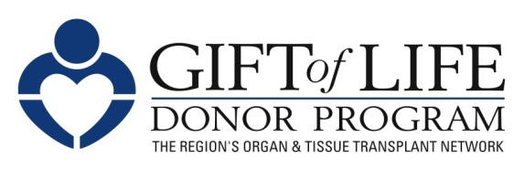

About Gift of Life Donor Program

Headquartered in Philadelphia, PA, Gift of Life Donor Program is the largest organ procurement organization (OPO) in the United States, serving 11.2 million people across Delaware, southern New Jersey and the eastern half of Pennsylvania. The non-profit, federally-designated OPO is part of the national network, UNOS, the United Network for Organ Sharing. Working in partnership with the 127 acute care hospitals and 14 transplant centers in its designated service area, Gift of Life helps give people a second chance at life. Since 1974, Gift of Life has coordinated more than 47,000 organs for transplantation and approximately one million life-enhancing tissue transplants.

The need for more donors is one of this country’s critical public health issues. Currently, there are more than 113,000 men, women and children awaiting a life-saving transplant in the United States, with an average of 20 people dying each day waiting for an organ. Just one organ donor can save up to eight lives, and one tissue donor can benefit more than 75 others.

Gift of Life’s devotion to the transplant community includes a “home away from home” for transplant patients and their families. Gift of Life Family House provides affordable lodging, meals and supportive services to those who travel to Philadelphia for transplant-related care. Since its founding in July 2011, the Family House has provided more than 56,000 lodging nights for more than 100,000 guests and served more than 200,000 meals.
Gift of Life Donor Program is recognized internationally for its leadership and scholarship in the field of organ and tissue donation. The Gift of Life Institute, an affiliate of Gift of Life, is the international leader in organ and tissue donation education, training close to 9,500 professionals from 39 countries since 2004.

Gift of Life Institute’s Transplant Pregnancy Registry International (TPR) studies post-transplant parenthood and the effects of medications on fertility and pregnancy. Since 1991, TPR has tracked more than 4,600 post-transplant pregnancies, sharing information with countless transplant recipients and their healthcare teams making family planning decisions.

With ongoing advancements in transplantation, the overall need for organ donation grows, as does the need for more registrants. Currently, in Gift of Life’s region, there are more than 5,000 men, women, and children awaiting life-saving transplants. Gift of Life encourages everyone to discuss organ donation with loved ones to make their personal preferences known.

For more information on organ donation or to register, go to www.donors1.org. It only takes 30 seconds.

01.2019

