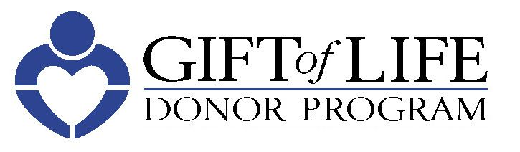
Organ and Tissue Donation Facts

- 20 people die each day waiting for an organ transplant.
- Every 10 minutes, another person's name is added to the list.
- There are more than 5,000 men, women and children in our region awaiting a life-saving organ transplant.
- Nationally, there are approximately 114,000 people waiting for an organ transplant.
- Just 1 organ donor can save up to 8 lives and 1 tissue donor can enhance the lives of more than 75 others.
- About Gift of Life Donor Program: Since 1974, Gift of Life has coordinated more than 47,000 organ transplants and approximately one million tissue transplants.
  - Gift of Life’s region is the eastern half of PA, southern NJ and DE, serving 11.2 million people.
  - Gift of Life’s annual donation rate ranks among the highest in the world, equating to 55 organ donors-per-million-population. Gift of Life serves the most giving region in the nation!
- About the Family House: Gift of Life Family House serves as a "home away from home" for transplant patients and their families by providing temporary, affordable lodging and supportive services to those who travel to Philadelphia for transplant-related care.
- Why are there so many people on the transplant waiting list? As advances in medicine have grown, transplants have become more successful and more people have been added to the national waiting list. At the same time, the number of donors has not grown as quickly as the number of people who are in need of organs and tissue.
- Is there an age limit for donating organs? No set age limit exists for organ donation. At the time of death, the potential donor's organs are evaluated to determine their suitability for donation. Therefore, people of any age wishing to become organ and tissue donors should indicate their decision to be an organ and tissue donor on their driver's license and inform their family that they wish to donate.
- Does my religion approve of donation? All of the major religions in this country approve of organ and tissue donation and consider it a gift and an act of charity.
- Does it cost anything to donate organ and tissues? No. Donation costs nothing to the donor's family or estate.
- Will donation change the appearance of my body? No. Donation neither disfigures the body nor interferes with funeral arrangements.
- Will my decision to become an organ and tissue donor affect the quality of my medical care? No. Organ and tissue recovery takes place only after all efforts to save your life have been exhausted and death has been declared. The doctors working to save your life are entirely separate from the medical team involved in recovering organs and tissues.

For more information about organ and tissue donation or to register,
visit donors1.org.
It only takes 30 seconds to register.

