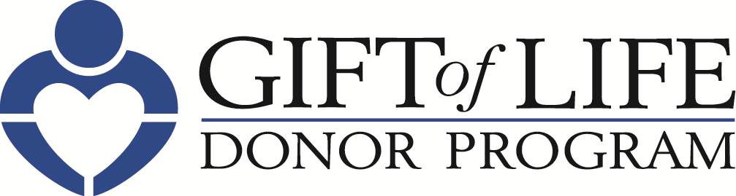 [HOSPITAL LOGO]

FOR IMMEDIATE RELEASE Contact: [Hospital PR Contact information]

Gift of Life Donor Program and [HOSPITAL NAME]
Recognize National Donate Life Month in April
– Gift of Life Encourages Individuals to Generate Hope, Advocacy and Passion
by Registering to Become an Organ, Tissue and Cornea Donor –

Philadelphia, April XX, 2019 – Each day, 20 people in the United States die while waiting for a life-saving organ transplant. [HOSPITAL NAME] is pleased to join the Hospital & Healthsystem Association of Pennsylvania (HAP) and Gift of Life Donor Program and organ procurement organizations throughout the country to inspire hope, advocacy and passion for National Donate Life Month and beyond. Gift of Life is encouraging individuals to register to become an organ, tissue and cornea donor.

“The number of people in need of transplants far exceeds the number of organs, tissues and corneas that are donated, and at Gift of Life, we’re passionate about educating people on the need to become an organ, tissue and cornea donor,” said Howard M. Nathan, President and CEO. “Registering to become a donor only takes about 30 seconds, but it’s one of the most meaningful ways individuals can inspire hope and change the life of someone waiting for a transplant.”

“As a health system, we are uniquely positioned to not only tend to the health of our patients, but to inspire our community to be mindful of wellness in all aspects of life,” said [HOSPITAL PRESIDENT/CEO]. “The more people we can inspire to become organ donors, the better we can serve our mission to be advocates for the well-being of our entire community.”

– more –
Individuals are encouraged to talk with family members and friends about registering as a donor. Each organ, tissue and cornea donor can help up to 75 people. To sign up, visit www.donors1.org.
Some important facts about organ, tissue and cornea donation:

- Anyone can be a potential donor regardless of age, race or medical history.

- More than 5,000 patients in the region await life-saving organ transplants. Thousands of others could benefit from life-enhancing tissue transplants.

- Only 47% of registered drivers in Pennsylvania have designated themselves as organ and tissue donors.

- With approximately 95,000 people across the nation awaiting a kidney, it is the organ in greatest demand, followed by liver, heart and lungs.

- Because conditions such as diabetes and hypertension are often more prevalent in the multicultural community, these individuals make up more than 50 percent of those on the national organ transplant list.

About Gift of Life Donor Program
Since 1974, Gift of Life has coordinated over 47,000 life-saving organ transplants and approximately one million tissue transplants. Gift of Life serves as the link between donors and patients awaiting life-saving organ and life-enhancing tissue transplants. Gift of Life’s coordination of over 55 donors-per-million-population ranks among the highest in the world. For more information about donation and to register, visit us at donors1.org.

About [HOSPITAL]

# # #

