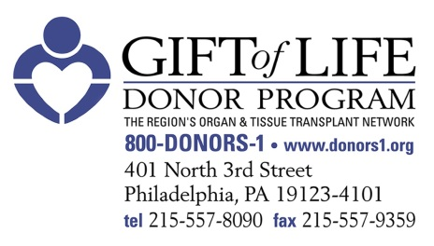

Gift of Life – HAP Newsletter Article for National Donate Life Month (April)

Each day, 20 people in the United States die while waiting for an organ transplant. Thousands more await a life-enhancing tissue transplant. Still, only 47 percent of Pennsylvanians have registered to become organ and tissue donors.

In honor of National Donate Life Month, [HOSPITAL NAME] is joining forces with the Hospital & Healthsystem Association of Pennsylvania (HAP) and Gift of Life Donor Program to improve donation practices and outcomes while also promoting the critical need to increase the number of registered donors.

Ensuring that we have effective donation practices and hospital-wide education in place is an important first step toward an effective and robust donation system. By encouraging hospital staff and their friends and families to register to become organ, tissue and cornea donors, [HOSPITAL NAME] aims to inspire hope, advocacy and passion among those waiting for a transplant.

“As a health system, we are uniquely positioned to not only tend to the health of our patients, but to inspire our community to be mindful of wellness in all aspects of life,” said [HOSPITAL PRESIDENT/CEO]. “The more people we can inspire to become organ donors, the better we can serve our mission to be leading advocates for the well-being of our entire community.”

Throughout the month of April - and throughout the year - [HOSPITAL NAME] encourages its staff to learn the facts and talk with their family members and friends about becoming advocates for organ donation.

The facts are compelling. In Pennsylvania, more than 5,000 people, and approximately 114,000 people nationally, are awaiting an organ transplant. Every 10 minutes, another person who needs a transplant is added to the national waiting list. Through being an organ donor, one individual can save up to eight lives, while tissue donors can improve the lives of up to 75 people. Donation is a possibility only after all efforts to save the patient’s life have been exhausted, tests have been performed to confirm the absence of vital signs, and brain death has been declared.

“Being an organ and tissue donor is one of the most meaningful and compassionate decisions a person can make,” said Howard M. Nathan, President and CEO of Gift of Life. “And it only takes about 30 seconds to register.”

To register to become an organ donor or for more information on ways generate hope, advocacy and passion for National Donate Life Month, visit Gift of Life’s website at www.donors1.org.

